**Task 2.**

**CREATE DATABASE student_database;**

**-- Connect to the "student_database"**

**\c student_database;**

**-- Create the student_table**

**CREATE TABLE student_table (**

**Student_id serial PRIMARY KEY,**

**Stu_name text,**

**Department text,**

**email_id text,**

**Phone_no numeric,**

**Address text,**

**Date_of_birth date,**

**Gender text,**

**Major text,**

**GPA numeric,**

**Grade text**

**);**

**INSERT INTO student_table (Stu_name, Department, email_id, Phone_no, Address, Date_of_birth, Gender, Major, GPA, Grade)**

**VALUES**

**('Naveen Kumar', 'Computer Science', 'Naveen.kumar@email.com', 9876543210, '111 Rajwada', '1998-05-15', 'Male', 'Computer Science', 3.7, 'A'),**

**('Shree Sharma', 'Mathematics', 'Shree.sharma@email.com', 9876543211, '112 Sanwer', '1999-03-22', 'Female', 'Mathematics', 3.5, 'B'),**

**('Dheeraj Patel', 'Physics', 'dheeraj.patel@email.com', 9876543212, '113 Indore', '1997-11-10', 'Male', 'Physics', 3.9, 'A'),**

**('Deepika Mishra', 'Biology', 'deepika.mishra@email.com', 9876543213, '114 Jaipur', '1999-07-08', 'Female', 'Biology', 3.2, 'C'),**

**('Sachin Verma', 'Chemistry', 'sachin.verma@email.com', 9876543214, '115 Rajwada', '1998-01-30', 'Male', 'Chemistry', 3.8, 'A'),**

**('Heena Gupta', 'History', 'heena.gupta@email.com', 9876543215, '116 Rajwada', '1997-09-05', 'Female', 'History', 3.4, 'B'),**

**('Vikas Singh', 'Economics', 'vikas.singh@email.com', 9876543216, '117 Rajwada', '1998-04-18', 'Male', 'Economics', 3.6, 'A'),**

**('Ritu Agarwal', 'Engineering', 'ritu.agarwal@email.com', 9876543217, '118 Rajwada', '1997-06-25', 'Female', 'Engineering', 3.3, 'B'),**

**('Rakesh Tiwari', 'Psychology', 'rakesh.tiwari@email.com', 9876543218, '119 Rajwada', '1999-02-14', 'Male', 'Psychology', 3.7, 'A'),**

**('Meera Yadav', 'English', 'meera.yadav@email.com', 9876543219, '120 Rajwada', '1998-08-20', 'Female', 'English', 3.1, 'C');**

**Task.2.3**

**-- Retrieve all students' information and sort by grade in descending order**

**SELECT \***

**FROM student_table**

**ORDER BY Grade DESC;**

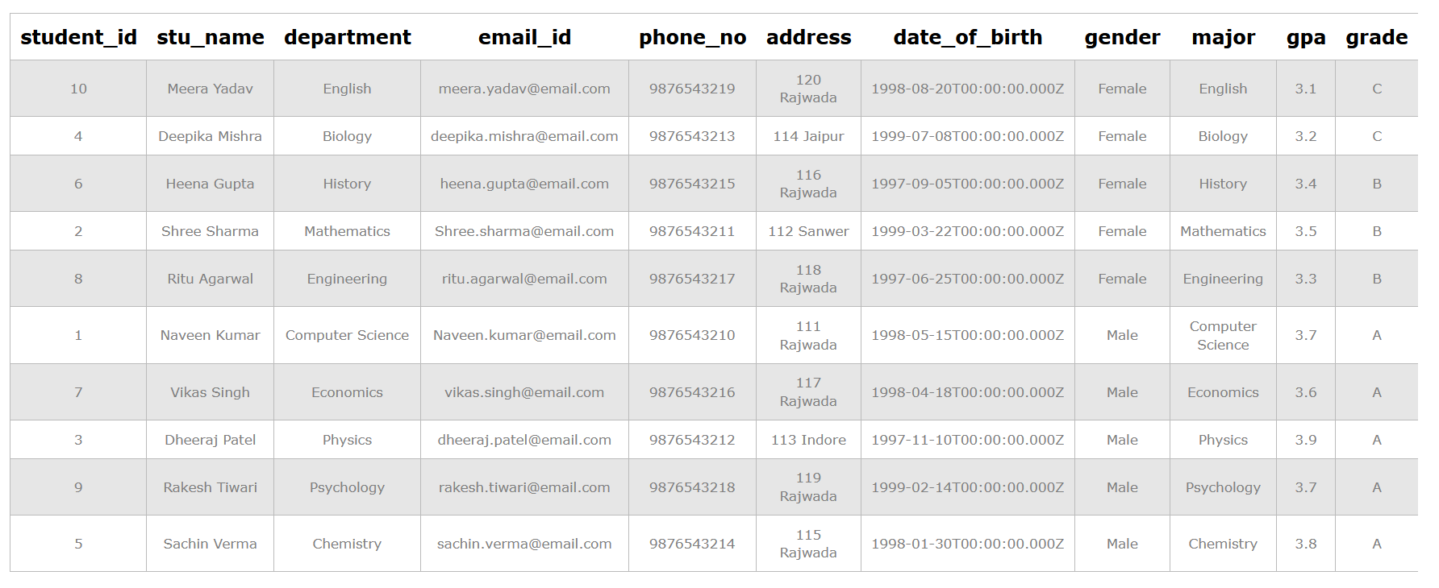

**Task.2.4**

**-- Retrieve information about all male students**

**SELECT \***

**FROM student_table**

**WHERE Gender = 'Male';**

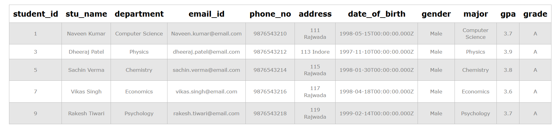

**Tasl.2.5**

**-- Fetch details of students with GPA less than 5.0**

**SELECT \***

**FROM student_table**

**WHERE GPA < 5.0;**

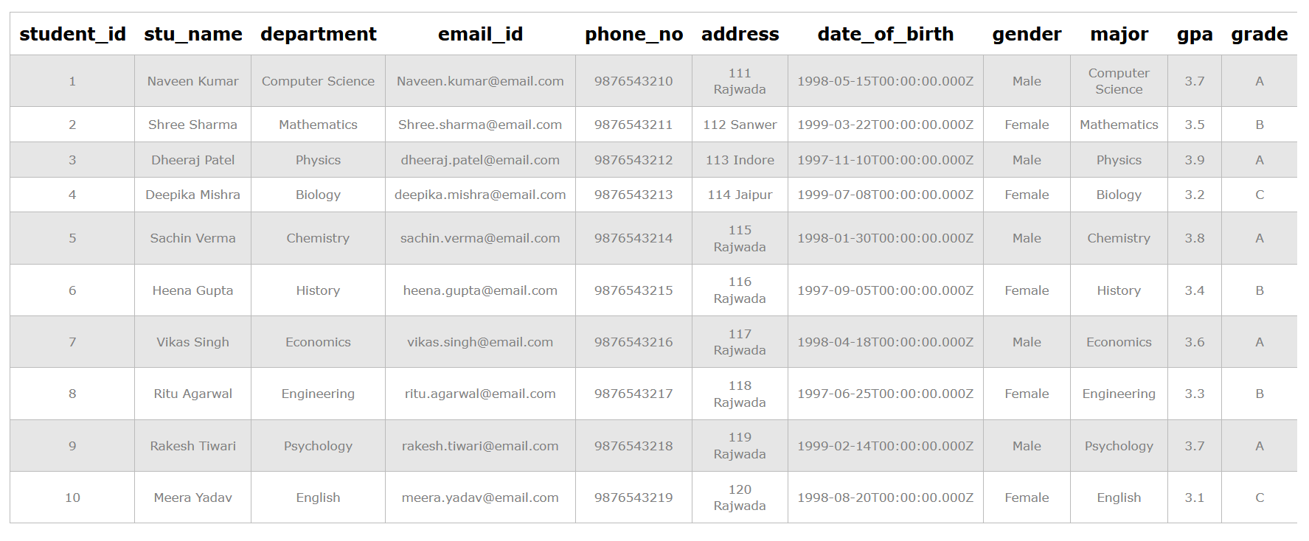

**Task2.6**

**-- Update the email and grade for a specific student (replace with the desired Student_id)**

**UPDATE student_table**

**SET email_id = 'new.email@example.com', Grade = 'B'**

**WHERE Student_id = 1;**

**Task2.7**

**-- Retrieve names and ages of students with a grade of "B"**

**SELECT Stu_name, EXTRACT(YEAR FROM AGE(current_date, Date_of_birth)) AS Age**

**FROM student_table**

**WHERE Grade = 'B';**

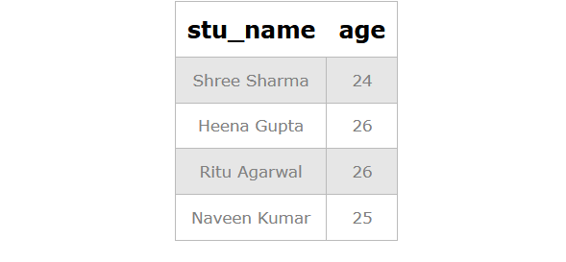

**Task 2.8**

**-- Group by Department and Gender, and calculate the average GPA for each combination**

**SELECT Department, Gender, AVG(GPA) AS Average_GPA**

**FROM student_table**

**GROUP BY Department, Gender;**



**Task2.9**

**-- Rename the table from student_table to student_info**

**ALTER TABLE student_table RENAME TO student_info;**

**Task2.10**

**-- Retrieve the name of the student with the highest GPA**

**SELECT Stu_name**

**FROM student_info**

**WHERE GPA = (SELECT MAX(GPA) FROM student_info);**

